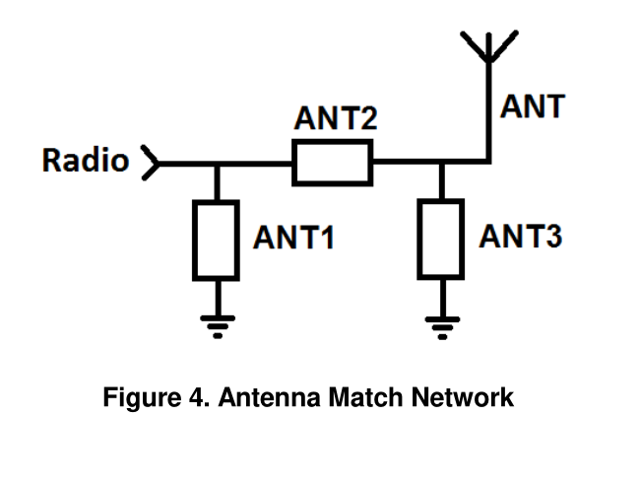

ANT1 DNP
ANT2 1.0 pF
ANT3 11.4 nH

